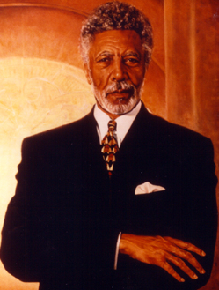
International & Area Studies
University of California, Berkeley
In association with
Peace & Conflict Studies
Presents
"Peace is More than the Absence of War"
A free Public Lecture by
Ronald V. Dellums
Former Congressman & Chair of the House Armed Services Committee

The Honorable Ron Dellums, globally renowned Afro-American peace and justice activist and former Congress Member from California's 9th District, will speak at University of California, Berkeley's International House at 2299 Piedmont Avenue on Thursday, November 18th, at 4:00 PM.
Dellums' talk, "Peace is More Than The Absence of War", is based on 27 years serving in the U.S. Congress while advocating for organized labor, universal healthcare, the environment, disarmament, and human rights. He will also share his vision and goals for the future.
The University of California, Berkeley is privileged to announce the endowment drive for the "Ronald V. Dellums Chair" in Peace & Conflict Studies. This endowment will honor his contribution to peace. The University's commitment to diversity and to the study of peaceful conflict resolution mirrors the Dellums legacy.
First elected to Congress in 1970 as an opponent of the Vietnam War, Dellums became a recognized expert in military and foreign policy and ascended to the Chair of the House Armed Services Committee. Among his many honors, Mr. Dellums is credited by Nelson Mandela with having provided leadership for the US boycott of South Africa, a campaign crucial in ending apartheid in South Africa.
Mr. Dellums is president of Healthcare International Management Company, a firm based in Washington D.C., with programs in southern Africa. He is currently advocating an AIDS "Marshall Plan" for Africa; meeting this month with the World Health Organization in Geneva to call on pharmaceutical companies, scientists, doctors and government officials to address the issue of AIDS. Dellums' new book, Lying Down With Lions, is expected to be published this December 1999.

