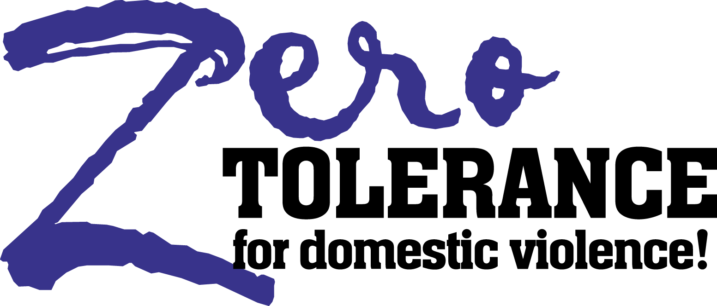

Zero Tolerance for Domestic Violence Initiative Awarded
Over $1.6 Million in Federal Grants

September 26, 2006 PRESS RELEASE
For Immediate Release

Martinez, CA – The Contra Costa County Board of Supervisors’ Zero Tolerance for Domestic Violence Initiative has been awarded two federal grants from the U.S. Department of Justice, Office on Violence Against Women. A two-year continuation grant in the amount of $1,317,924 for Grants to Encourage Arrest Policies and Enforcement of Protection Order Programs and a $349,811 two-year grant for Safe Havens: Supervised Visitation and Safe Exchange Grant Program (Safe Havens).

Grants to Encourage Arrest will allow the county to continue with important domestic violence response systems with two key enhancements: hiring a Domestic Violence Misdemeanor Detective in the Office of the Sheriff and expanding restraining order and immigration assistance. The Office of the County Administrator will serve as the lead agency and will be responsible for administrative and fiscal oversight of the projects. Project partners are: Community Violence Solutions, STAND! Against Domestic Violence, Bay Area Legal Aid, Superior Court of California - County of Contra Costa, Contra Costa County Probation Department, Contra Costa County Office of the Sheriff, Contra Costa County Office of the District Attorney, San Pablo Police Department, and the Richmond Police Department.

Safe Havens will establish a supervised visitation center in West County for families impacted by domestic violence, child abuse, sexual assault, and stalking. As a collaborative the supervised visitation program is a public-private partnership that additionally includes participation from John F. Kennedy University and Familias Unidas.

“Since its inception in 2001, Zero Tolerance for Domestic Violence has been recognized for its innovation in the area of system change through a comprehensive, coordinated, community-wide approach that interrupts the progressive cycle of violence, recognizing the cost effectiveness of integrated and collaborative service strategies,” states Devorah Levine, Zero Tolerance for Domestic Violence Coordinator, “These grants further the goals of Zero Tolerance for Domestic Violence while providing an opportunity to leverage additional dollars to fight domestic violence in Contra Costa County.”

Contact: Contra Costa County Administration
925-335-1092

The Grants to Encourage Arrest and Safe Havens proposals were prepared by Development Consulting Network

